A close up of a logo  AI-generated content may be incorrect., Picture



Project Title

ToyCraft Tales: Tableau’s Vision into Toy Manufacturer Data

**Team ID : LTVIP2025TMID60914**

**Team Size : 3**

**Team Leader : Vaishali Lanka**

**Team member : Vaishnavi devi pericharla**

**Team member : Veera Lalitha chikkam**

# INTRODUCTION

## Project Overview

This project explores the US toy manufacturing industry using Tableau. It focuses on analyzing patterns, trends, and state-wise performance from the years 2005 to 2016.

The dashboard and storyboards help stakeholders derive insights for strategic decisions.

## Purpose

To visualize toy manufacturer data to identify trends over time, state contributions, and distribution of manufacturing units using Tableau’s interactive dashboards.

# IDEATION PHASE

## Problem Statement

Toy manufacturers lack visibility into historical production data and geographic performance, making it difficult to plan future strategies.

## Empathy Map Canvas

* **Who?**: Toy manufacturers, decision-makers, stakeholders
* **Think & Feel?**: Want clarity, insight into trends
* **See?**: Fragmented or raw data
* **Hear?**: Need for dashboards
* **Say & Do?**: Seek visual insights
* **Pain?**: No centralized visibility
* **Gain?**: One-stop analytical dashboard

## Brainstorming

* Use Tableau for interactive visuals
* Analyze time-based decline/growth
* Use maps and pie charts for geographic spread
* Show high/low performing states

# REQUIREMENT ANALYSIS

## Customer Journey Map

|  |  |  |  |
| --- | --- | --- | --- |
| **Stage** | **Actions** | **Emotions** | **Pain Points** |
| Data Access | Load CSVs into Tableau | Curious | Raw data not easily readable |
| Visualization | Create charts, dashboards | Confident | Layout alignment issues |
| Insights | Story creation, analysis sharing | Informed | Limited export options |

* 1. **Solution Requirement**
* Tableau Desktop
* Clean CSV dataset
* Graphical representation of key metrics
* Dashboard and Story integration
  1. **Data Flow Diagram**

**CSV File → Tableau Data Pane → Visual Charts → Dashboard → Insights**

* 1. **Technology Stack**
* **Tool**: Tableau
* **Language**: Drag-and-drop interface, no code
* **Data**: CSV - Week 39: US Toy Manufacturers (2005–2016)

# PROJECT DESIGN

## Problem Solution Fit

The project fits by transforming raw manufacturer data into valuable visual narratives using Tableau's interactive capabilities.

## Proposed Solution

An interactive Tableau dashboard and story board to showcase manufacturer trends, top-performing states, and manufacturer counts.

## Solution Architecture

* **Input**: Dataset (CSV)
* **Process**: Import → Clean → Visualize
* **Output**: Dashboards + Storytelling

# PROJECT PLANNING & SCHEDULING

* 1. **Project Planning**

|  |  |  |
| --- | --- | --- |
| **Phase** | **Timeline** | **Tools Used** |
| Data Collection | Day 1 | CSV, Excel |
| Visualization | Days 2–3 | Tableau |
| Dashboard Design | Day 4 | Tableau |
| Story Creation | Day 5 | Tableau |

# FUNCTIONAL AND PERFORMANCE TESTING

## Performance Testing

* **Dashboard Loading Time**: Less than 2 seconds
* **Filter Responsiveness**: Immediate
* **Story Navigation**: Smooth across views

# RESULTS

## Number of Manufacturers Over Time

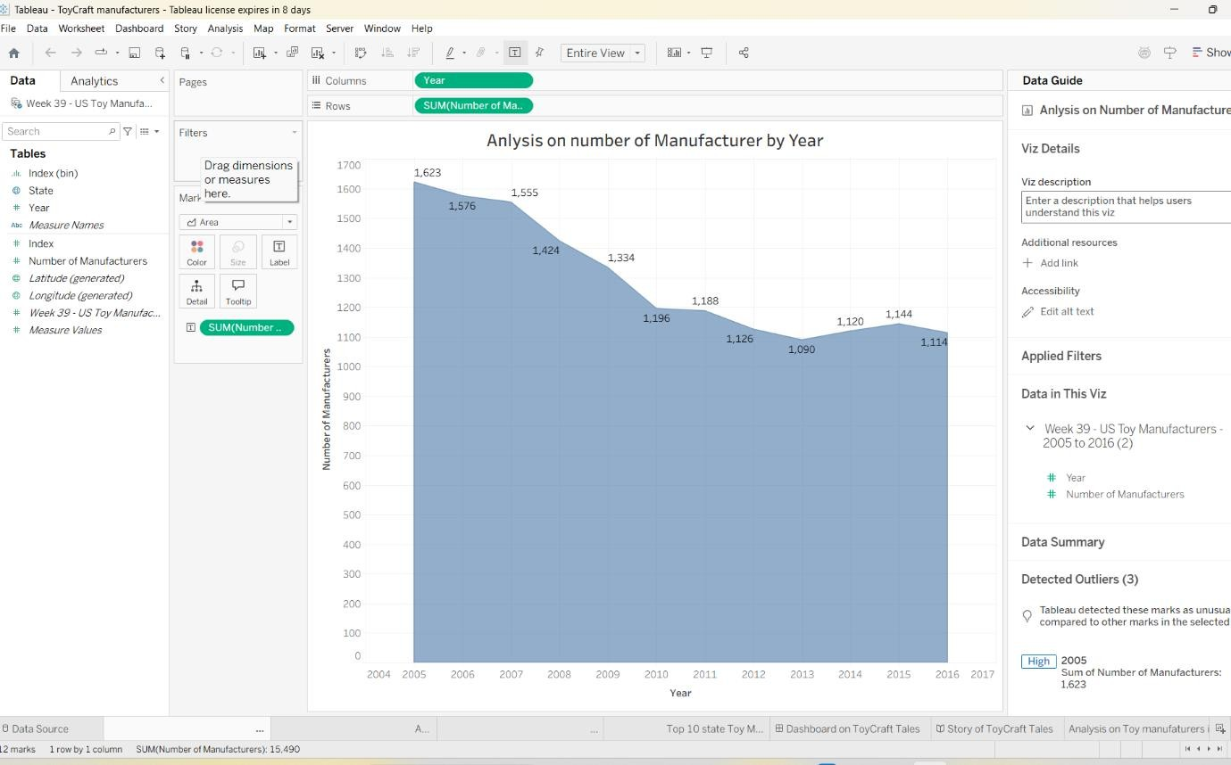Chart showing decline in manufacturers from 2005 to 2016

## Index Distribution of Manufacturers

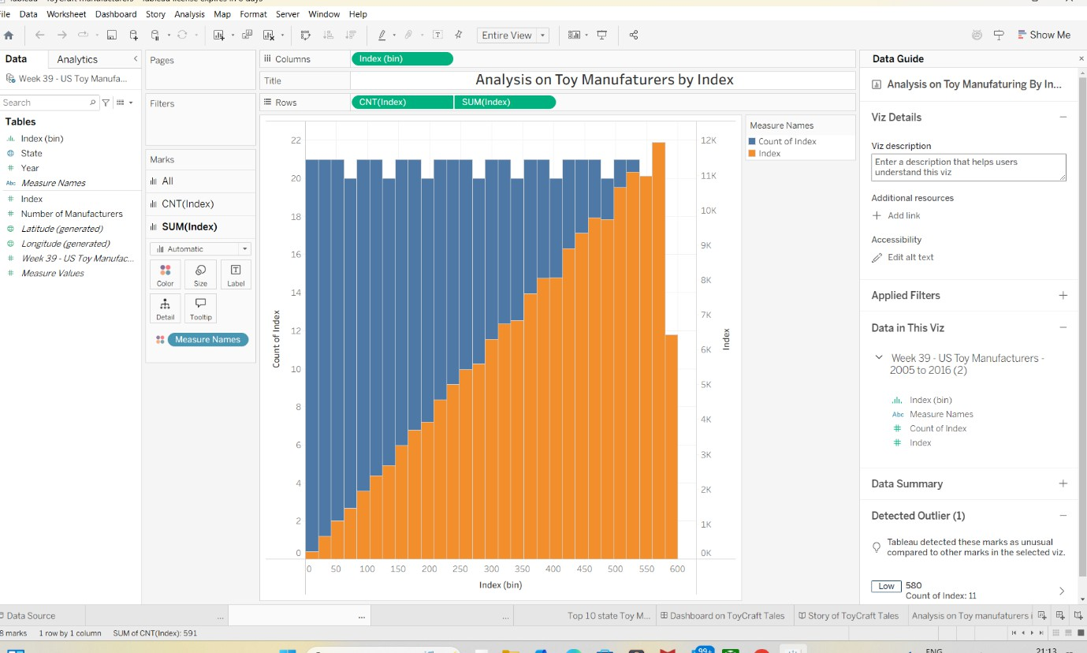Bar chart showing count and sum of index

## Measure Comparison Chart

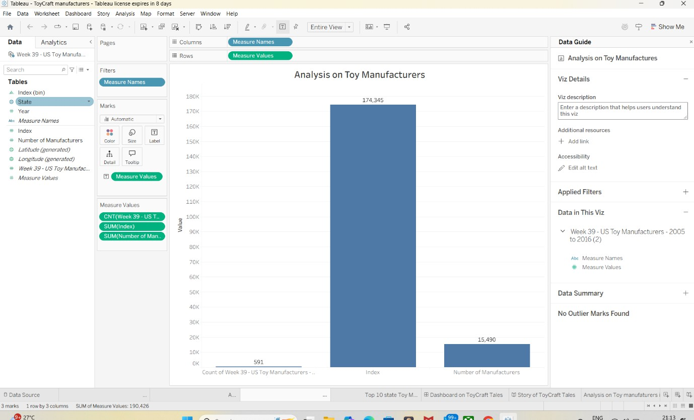Vertical bars for index and manufacturer count

## Top 10 States by Manufacturer Count

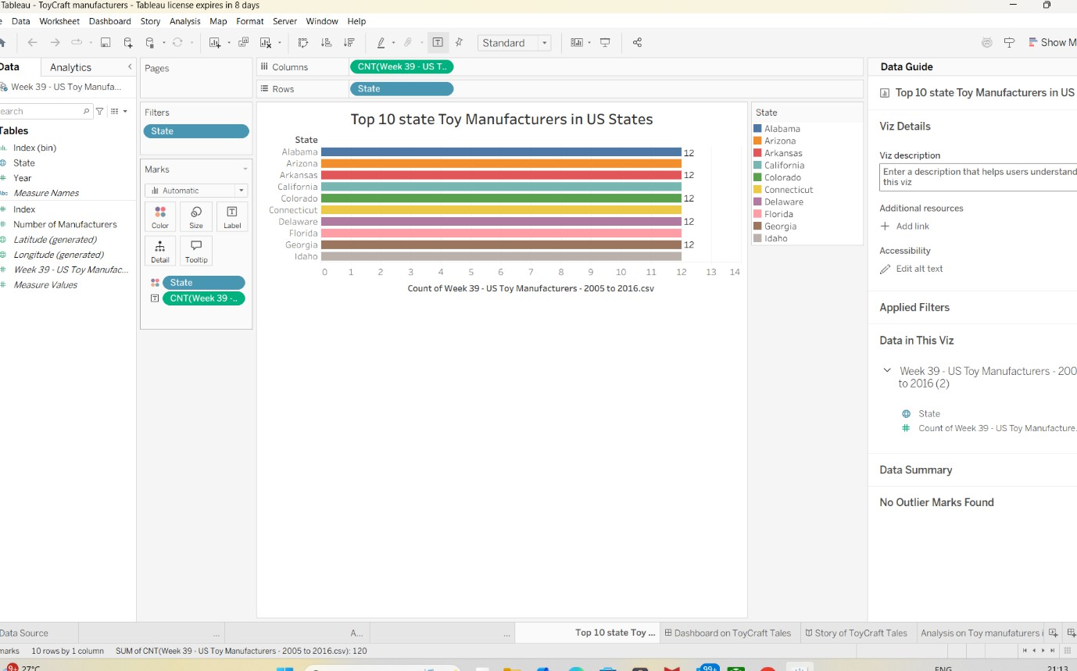Horizontal bar chart

## Pie Chart – Index by States

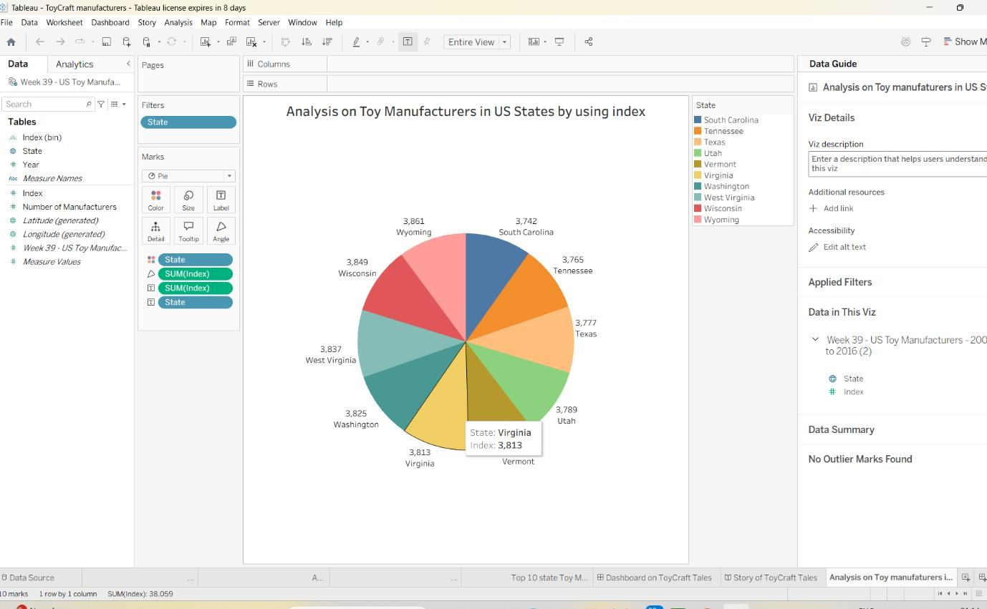Pie chart distribution of index

## Final Dashboard View

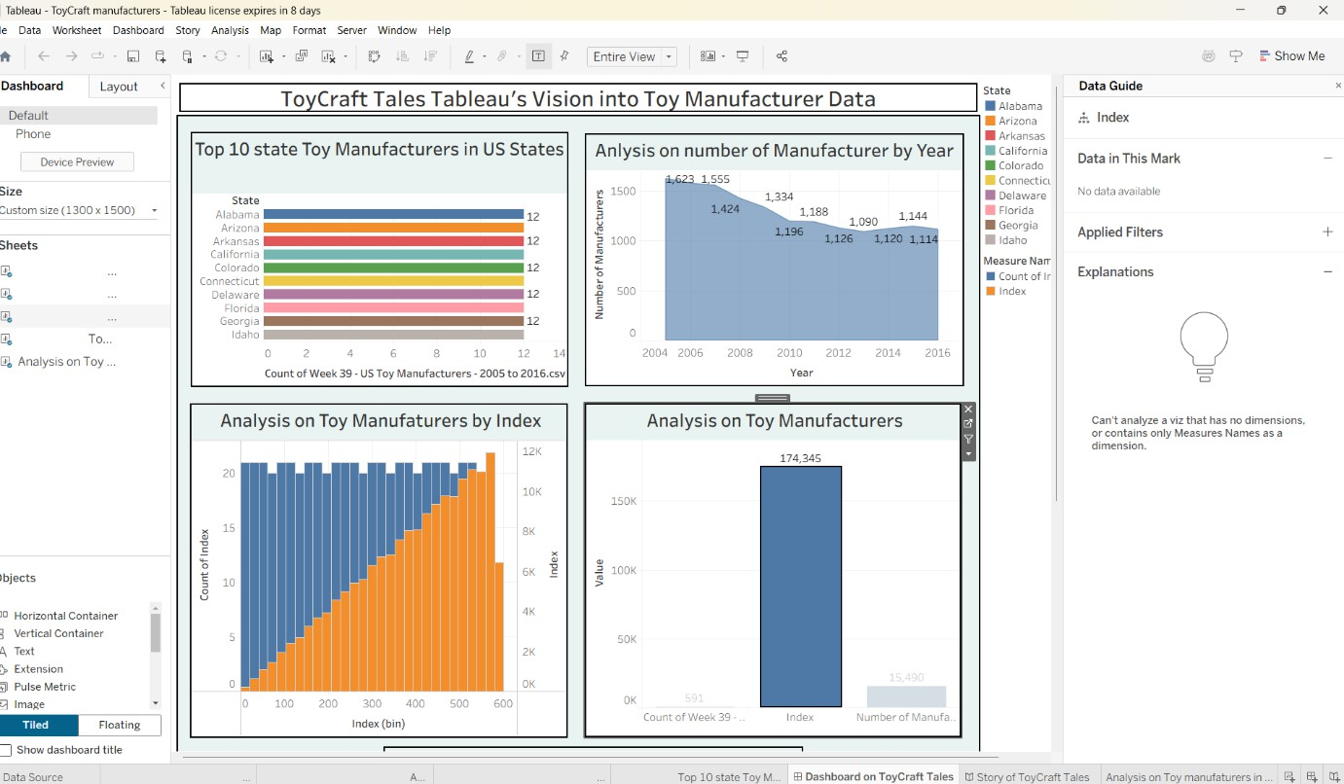Full Tableau dashboard

## Storyboard View

Story point with navigation tabs

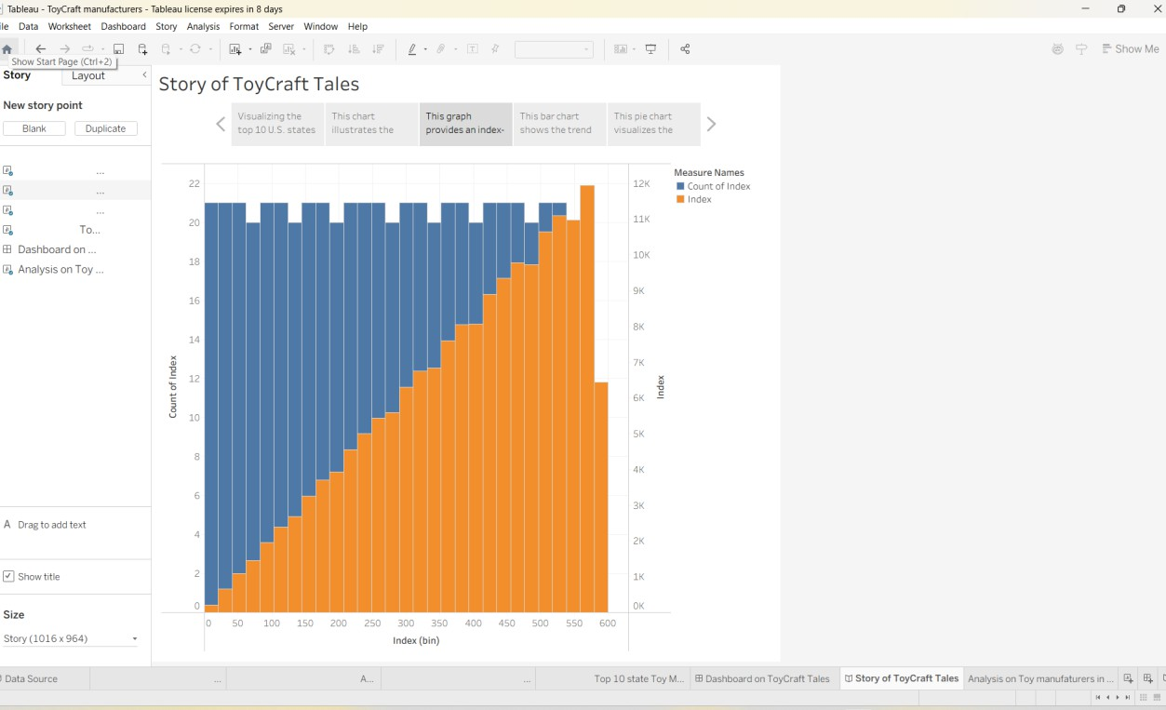

# ADVANTAGES & DISADVANTAGES

## Advantages

* Interactive and dynamic visuals
* Fast insights without programming
* Clear trend and state-wise distribution

## Disadvantages

* Limited customization outside Tableau
* Desktop version has licensing limits
* No predictive analytics

# CONCLUSION

The Tableau-based visualization system successfully uncovers historical trends in toy manufacturing, enabling better strategic planning and stakeholder insights.

# FUTURE SCOPE

* Integration with live data sources
* Predictive analytics using Python/ML
* Mobile responsive dashboards
* Export functionality for reports

# APPENDIX

## Source Code

*No programming used – Tableau visual interface*

## Dataset Link

Dataset: Week 39 – US Toy Manufacturers (2005–2016)

## GitHub & Project Demo Link